**Kinship Support Program Tips**

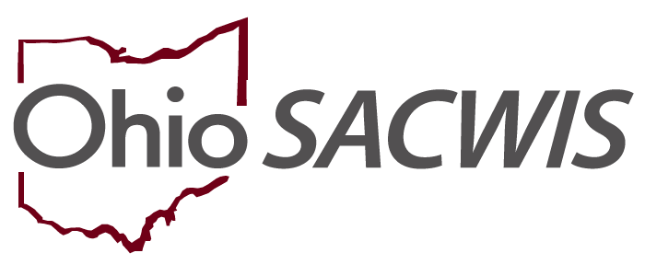

**Knowledge Base Article**

Table of Contents

Overview 3

Steps for Ensuring KSP Payments 3

Overpayments 3

Troubleshooting 3

Frequently Asked Questions 4

Eligibility 5

Placement 6

Foster Licensure/Waivers 7

Payment 9

Out of State Providers 9

Kinship Assessment 10

Miscellaneous 10

KSP Program Flow 11

Overview

Kinship Support Payments (KSP) began to eligible caregivers in 2021, providing a maximum of 6 months of payments for each kin child placed in the home. The intent of this article is to provide guidance on ensuring these payments are generated and paid as intended.

Steps for Ensuring KSP Payments

To allow Kinship Support Payments to be generated for a placed youth:

1. An inquiry with a *Reason for Inquiry* of **Provider Interest/Child of Interest** and *Provider Type*of **Kinship-Relative** or **Kinship-Non-Relative** must be screened in and linked to a Provider record, using the correct Person ID of the youth being placed.

For more information: [Creating a Provider Record from an Inquiry](https://jfskb.com/sacwis/index.php/provider/1004-creating-a-provider-record-from-a-provider-inquiry)

1. The youth must have a placement record with a status of Completed on the Provider ID created by or linked to the inquiry created above.

For more information: [Recording a Placement](https://jfskb.com/sacwis/index.php/case/83-placement/1012-recording-a-placement-record)

1. Provider Payment Information must be entered for the caregivers.

For more information: [Adding Payment Information for a Provider](https://jfskb.com/sacwis/index.php/financial/105-payment/70-adding-payment-information-for-a-provider)

1. The Provider Type status must be Approved or Court Approved to start KSP, meaning either a Kinship Assessment has been final approved by a supervisor for the youth’s current placement episode or the Court Approved status has been manually entered for the youth. If the status is Pending or Pre-Approved, Pending Assessment, payments will not be made.

For more information: [Completing a Kinship Assessment](https://jfskb.com/sacwis/index.php/provider/131-kinship/989-completing-a-kinship-home-assessment)

Overpayments

These occur when a youth leaves a Kinship home and the custodial agency does not end the placement record promptly. The system will continue to pay a kinship caregiver with a non-end-dated placement record for up to six months. If a placement is retroactively ended and payments were already made to the caregiver, the system will automatically create a repayment plan.

Therefore, it is critical to end-date a placement as soon as a youth leaves the kinship home.

Troubleshooting

1. To determine why caregivers may not be receiving payments, check for exceptions in Ohio SACWIS (Financial tab > Payment sub-tab > Kinship Support Program left-hand link > Exceptions tab (default). Enter in the Person or Provider ID in the appropriate search field which will display any issues which are impeding payment.

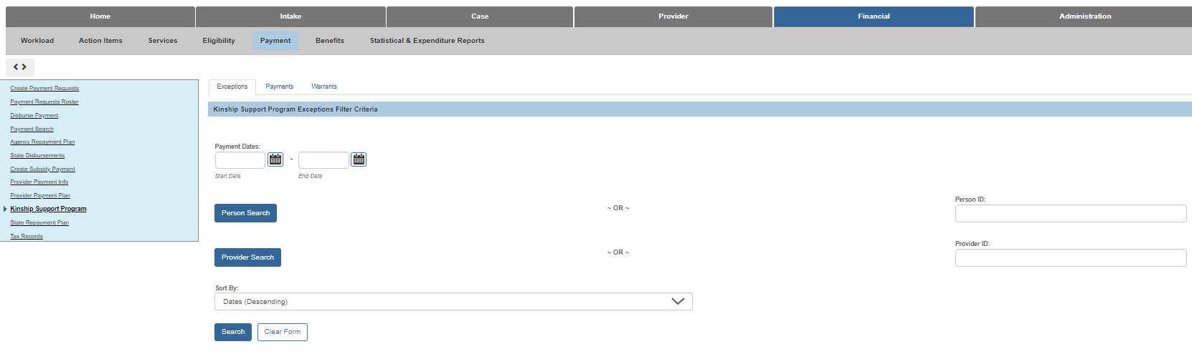

The system will display multiple error messages, if applicable, and include:

* The Provider has a Provider Type Status of either Pending or Pre-Approved Pending Assessment.
* A Kinship Assessment does not exist for the Placement Provider.
* Current Payment Information does not exist for the Provider.
* The Provider has a Provider Type Status of Denied.

1. Check to make sure the youth is placed on the same Provider ID as the approved Kinship Assessment. Duplicate Provider IDs sometimes exist.
2. Ensure the Person ID for the youth used in the inquiry is the same Person ID of the placed child.
3. Each placement episode must have a separate inquiry to create the Kinship Provider type. For instance, if a youth is placed for 3 months with a kinship provider, returns home for 2 months, then returns to placement with the same kinship provider, a new inquiry and approved Kinship Assessment must be completed. The former Approved Kinship Assessment and provider type cannot be used for a subsequent placement episode.
4. Kinship providers will continue to be paid if a child is AWOL or on placement leave during the 6 months service authorization period.
5. The State Kinship Care service authorization cannot be modified by PCSA users except by end dating the placement, which will end-date the service authorization.

Frequently Asked Questions

These questions come from the 2021 webinar held when the Kinship Support Program was introduced. The questions and answers have been revised and reformatted to better reflect the current status of the program.

Eligibility

1. **Can a family receive OWF benefits in conjunction with KSP?**

No. At initial application and recertification, caseworkers should ask caretaker relatives applying for benefits for children if they are in receipt of KSP payments. Each month the Office of Family Assistance will send a report of children newly in receipt of KSP payments.

1. **Does KSP impact income eligibility for OWF SNAP?**

For OWF and SNAP the policy is as follows: A child for whom KSP payments are being received cannot receive Ohio Works First (OWF) benefits. (Ohio Administrative Code 5101: 1-23-10). Additionally, assistance groups that include children for whom KSP payments are received have two options regarding how payments will affect their Supplemental Nutrition Assistance Program (SNAP) benefits: • Option 1: Include the child, for whom a KSP payment is received, as a member of the SNAP assistance group, which means the KSP payment will count as unearned income when determining eligibility for the assistance group’s SNAP benefits; or • Option 2: Do not include the child for whom a KSP payment is received as a member of the assistance group, which means the KSP payment will not be considered when determining eligibility for SNAP benefits. (Ohio Administrative Code 5101: 4-6-03). Each month the Office of Family Assistance will send a report of children newly in receipt of KSP payments. The Kinship Support Program will not be included in the income calculation for determining eligibility for publicly funded child-care.

1. **Will people be able to get OWF funds if they don't get certified?**

When a family is no longer able to receive KSP, they could potentially be eligible for OWF if eligibility requirements are met and an application is submitted.

1. **What about Child Support matches in Ohio SACWIS? Would the kin complete the CSEA application?**

KSP is only available to kinship caregiver who take placement of a child in a Title IV-E Agency's custody; therefore, child support referrals are still required to be submitted by the Title IV-E Agency.

1. **Approved relatives receiving KSP funds cannot apply for or receive OWF assistance for placement until their KSP payment timeline expires, correct?**

Correct. A child for who KSP payments are being received cannot receive OWF. Therefore, the family may apply for OWF once KSP payments end.

1. **What happens when the 6-month time period expires, and the caregiver chooses not to become a certified foster parent? If they are related they could get OWF, but if they're not related are we required to continue the payment out of our agency funds?**

A child is eligible to receive OWF if they are residing with a parent, specified relative or legal guardian or custodian. So, if the family is interested in child only OWF when KSP runs out, they must meet the living arrangement requirement. The caretaker does not have to be a relative to receive child only OWF, but they would have to be a legal guardian or custodian. It will be at each agency's discretion as to whether they choose to pay the kinship caregivers on top of the KSP payments and/or after the 6 month time period.

1. **If PCSA never took custody and gave the kinship family temporary/legal/ permanent custody would those families be eligible for KSP?**

In order to be eligible for KSP payments, the PCSA must have custody of the child or the child must be in the care and placement responsibility of a Title IV-E agency, so no, they would not be eligible.

1. **Given that there are counties that grant Temporary Custody to relatives without the PCSA ever holding custody, will there be any guidance from DCY about how to handle these situations moving forward?**

As this is based on county practice, we would suggest that a PCSA and the Court works together to achieve the best possible outcome for the children. However, all kinship caregivers, regardless of custody status, are eligible for navigation services through OhioKAN. Navigators will identify resources and supports within the family’s community. OhioKAN can be contacted at 844-OhioKAN or at the website: <https://ohiokan.jfs.ohio.gov/> .

Placement

1. **When a child AWOLs, Ohio SACWIS has them on leave but still placed in the kinship home--will payment end or continue during leave time?**

Payments will be issued for children who are on leave until the child returns to the kinship placement or the 6-month eligibility terminates.

1. **If a child is placed in a home for longer than 30 days, but is removed from the home prior to the kinship family assessment completion, will Ohio SACWIS still generate payments once the assessment is complete?**

Once the Kinship Assessment is marked as completed in Ohio SACWIS, the kinship support payment will be issued for the duration of placement, even if the placement is now ended.

1. **How would we know if a service authorization has been created for a kinship caregiver?**

The service authorization will display under the **authorize** link on the placement and display the State - Kinship Support Program service.

1. **Can a foster parent for a private agency take placement as a kinship care giver and receive KSP or should they be paid the foster parent per diem?**

If a caregiver is certified as a foster parent, the placement is a foster care placement and the home needs to be paid accordingly.

1. **If a kinship home is approved by a PCPA (rather than the PCSA), I assume the home belongs to the private agency and the rates are determined by the PCPA?**

If the kinship caregiver gets certified by a private agency, then the rate should be determined by negotiation between the private agency and the PCSA with custody of the child.

Foster Licensure/Waivers

1. **Many kinship caregivers do not want to be licensed as foster parents. Is it correct that there is not a requirement for them to become a licensed caregiver? And what will OhioKAN provide them? Is there funding through them? I'm not aware of any financial supports they offer.**

Correct, there is not a requirement for kinship caregivers to become licensed caregivers. OhioKAN provides navigator services to assist kinship and post adoptive families with locating resources and supports for those placements. OhioKAN does not provide payments or funding directly to families but has limited flexible funding to support families on a case by case basis as needed.

1. **If the relative receives waivers to become a foster parent for their kin, and their involvement with the child ends, can the relative continue their certification or does it only apply to the child that was placed?**

A kinship caregiver who becomes certified with an approved waiver will be certified to provide foster care to kinship children only. The caregiver and the recommending agency can discuss the option for continuing the certification. If waivers were required for certification, then the caregiver may only care for kin. If the caregiver can later meet the requirement that was waived, an amendment to the home study could be completed to make the caregiver a regular foster parent able to take additional children.

1. **Do kinship caregivers need to do foster parent training?**

A recommending agency may submit a waiver request to waive any training required to be a certified foster parent.

1. **Will requests to waive training requirements be approved on a case by case basis? Will agencies be “required” to waive training if requested to do so by the kinship provider?**

Training waivers are to be requested on a case by case basis. Agencies are not required to waive training if the agency deems that training is appropriate. However, a caregiver may choose to be certified through another agency.

1. **An agency can waive the requirement for pre-service training, but may they waive the ongoing training that all other foster parents are required to attend to remain licensed?**

A recommending agency may request to have ongoing training waived but is not required to waive training if the agency deems that training is appropriate.

1. **If the Kinship family is going to financially be relying on per diem of kinship youth being placed in the home, is that an issue while licensing them as foster parents?**

A foster home applicant shall have income sufficient to meet the basic needs of the household. Funds can be used by families for the care of their kin.

1. **A kinship caregiver who is licensed can only accept specific kin child (children). Would they be able to accept a different kin child if needed later?**

Yes, they can accept different kin at a later date. Any waivers granted should be re-evaluated to ensure they are still appropriate for the new kin being considered for placement. Any new waivers needed at that time will need to be submitted to DCY.

1. **Once kinship providers are licensed, will the children placed with them be considered foster children or will they still be considered kinship? The reason I ask is that foster families are under strict rules related to what they can disclose about the foster children. Our kinship families may not be as discrete.**

Once the caregivers become certified, they will be foster children placed in the home to enable the family to receive the full foster care per diem.

1. **Is there any chance that Ohio SACWIS will be modified to allow agencies to identify those families as kinship families who have become licensed?**

Agencies may utilize the Pursuing Foster Licensure tab on the Provider record to document this. This is also added to 4281 reports which will add to the agency's Total Reimbursable Days.

1. **If an agency does not train or license their own homes, who will provide this training and licensure?**

If a kinship caregiver chooses to pursue foster care certification, they should be referred to private agencies that certify foster homes.

1. **Are there instructions for submitting waivers?**

Here is the SACWIS Knowledge Base for submitting waivers: <https://jfskb.com/sacwis/index.php/provider/102-other/382-creating-awaiver-request>

1. **How long does the waiver process usually take?**

Waivers will be reviewed as they are received.

1. **Would a PCSA have to accept a kin-only foster home study for a child in another PCSA’s custody?**

The kinship caregiver ultimately decides where to apply to become a certified foster parent.

1. **Besides waivers for training, are there waivers for things such as criminal history?**

Waivers may be requested for any non-safety requirements.

Payment

1. **Is there an option for the KSP to be direct deposited rather than by warrant alone?**

Kinship caregivers can request EFT or check as the payment method. This can be entered on the Provider Payment Information within Ohio SACWIS. Payment is not provided through gift cards.

1. **Will the information be pulled into the 4280/4281 reports from somewhere in Ohio SACWIS or will the information need to be manually entered by a worker in the 4280/4281 reports?**

Kinship Support Program will display in the 4280 reports for expenditure information. This will not need to be manually entered.

1. **Do agencies need to add provider payee information for anyone on the exception report?**

Yes, agencies will need to add provider payment information for all payment exceptions.

1. **Is the payee portion of Ohio SACWIS going to be editable? Currently once created you cannot modify the address in the payee section.**

Provider payment information is not modifiable after created, but agencies can record a new record.

1. **Will the State be paying KSP at first but eventually the counties will be responsible?**

No, the KSP program is a DCY program and payments will be from the state. There is no expectation that PCSA will be responsible for KSP payments.

1. **Is there a knowledge base article on how to enter Provider Payment information?**

Yes - it may be found at <https://jfskb.com/sacwis/index.php/financial/105-payment/70-adding-payment-information-for-a-provider>

1. **If a kinship family loses a check who do they report it to for a replacement?**

If there are any issues with a payment being lost, stolen, etc., please use the instructions listed in the following Knowledge Base article: <https://jfskb.com/sacwis/index.php/financial/105-payment/1017-process-for-returned-voided-fraudulently-redeemed-warrants>.

Out of State Providers

1. **If an out of state ICPC was completed but they did not provide the ETN background check numbers will they get a payment?**

As long as the ICPC record in Ohio SACWIS displays that the placement may be made, KSP payments will be issued.

1. **Are we expected to enter the home study received from another state via ICPC?**

Functionality has been designed to look at the ICPC record. Alternatively, agencies may either record a status of Court Approved on the provider or copy the home study completed from the other state into the Kinship Assessment.

1. **So ICPC kinship home studies are eligible for this program too?**

Yes, a kinship caregiver in another state who has placement of a child in the custody of an Ohio PCSA is eligible to receive KSP payments.

Kinship Assessment

1. **If County A has custody and the children are placed with a relative in County B, who completes the kinship home assessment (County A or County B)?**

The PCSA that has custody of the child is responsible for completing a kinship home assessment. If the home is in a different county, the PCSA with custody may ask the other PCSA to complete a courtesy home assessment.

1. **Sometimes children are placed emergently and in SACWIS that is given a provisional approval (Pre-Approved, Pending Assessment status). Will the KSP payments be paid to that kinship caregiver from that provisional approval date or the actual approval date after all paperwork and assessment with the family are received?**

Once the kinship assessment is completed within Ohio SACWIS, payments will be provided the kinship caregiver back to the Placement Begin Date, not the approval date of the assessment.

1. **If the kinship caregiver only has placement for a few days, does a home assessment still need to be completed for them to get KSP?**

If the placement is less than 30 days and no Kinship Assessment is completed, the caregiver will be issued a KSP payment(s).

Miscellaneous

1. **Will the County JFS need to add Kinship Payment Program to their current PRC Plan?**

No, the KSP program does not need added to the county PRC plan. The KSP program is not funded by PRC.

1. **Will the Kinship Permanency Incentive Program still be administered by PCSA?**

Yes. There are no changes to the Kinship Permanency Incentive Program.

KSP Program Flow

Please refer to this chart for a simplified view of the KSP process.

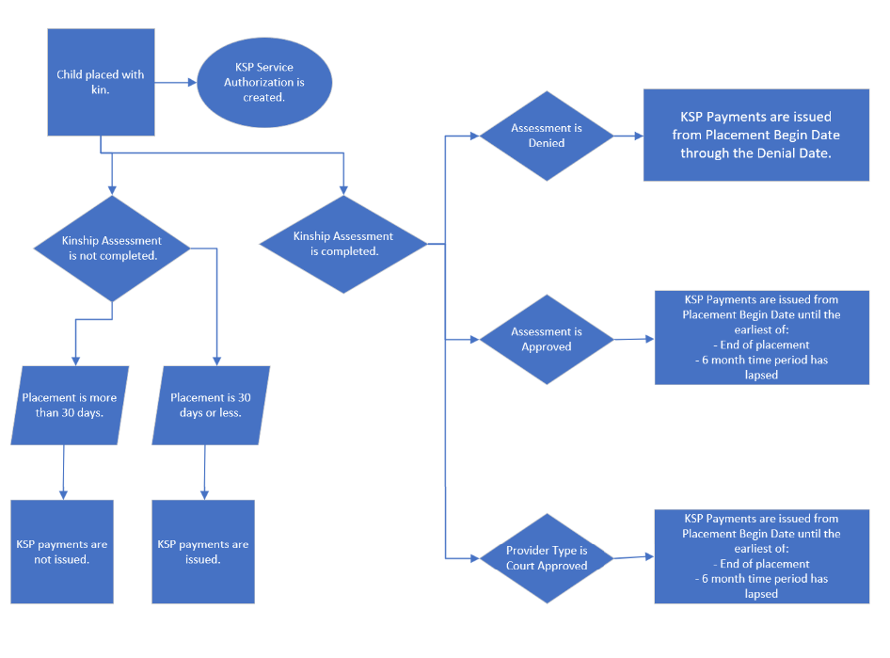

If you need additional information or assistance, please contact the Bureau of Children Services Operational Support’s [Customer Care Center](https://odjfs2.my.site.com/CustomerCareCenter).